30 people were given snacks to eat while they were at a “Healthy Choices” luncheon. They were then asked to rate their snacks on a 1 (not healthy) to 10 (very healthy) point scale. The ratings are below.

cheese candy fruit

6 3 4

7 2 5

8 3 6

6 4 5

5 2 4

6 1 7

7 2 6

6 3 5

5 4 3

7 3 6

Is there a significant difference (using p<.05) in the ratings for snacks?

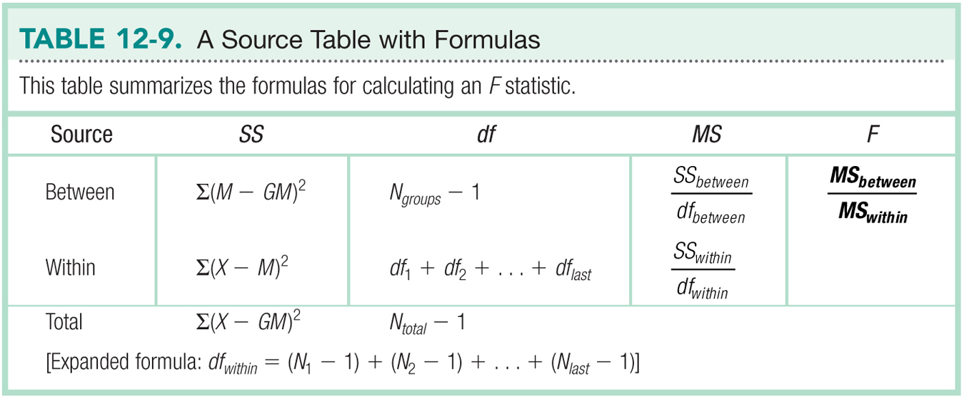

*n

|  |  |  |  |  |
| --- | --- | --- | --- | --- |
| Variance Type | SS | *df* | *MS* | *F* |
| Between groups  (IV) | 67.2 | 3-1 = 2 | 33.1 | 31.11 |
| Within Groups  (error) | 29.1 | 10-1+10-1+10-1  27 | 1.08 | Xx |
| Total | 96.3 | 30-1  29 | Xx | Xx |

|  |  |
| --- | --- |
| Step 1 | Is dv scale? Yes, interval scale  Normal? N = 30, yes  Random selection? Probably not, could randomly assign  Homogeneity - ? yes they are equal |
| Step 2 | R: cheese =/ candy =/ fruit  N: cheese = candy = fruit |
| Step 3 | > summary(chapter12)  cheese candy fruit  Min. :5.0 Min. :1.0 Min. :3.00  1st Qu.:6.0 1st Qu.:2.0 1st Qu.:4.25  Median :6.0 Median :3.0 Median :5.00  Mean :6.3 Mean :2.7 Mean :5.10  3rd Qu.:7.0 3rd Qu.:3.0 3rd Qu.:6.00  Max. :8.0 Max. :4.0 Max. :7.00  >  Homogeneity: calculate the sds  Source table   |  |  |  |  |  | | --- | --- | --- | --- | --- | | Variance Type | SS | *df* | *MS* | *F* | | Between groups  (IV) | SUM OF SQ  VARIABLE  67.2 | DFN  2 | Divide yourself  33.1 | F  31.11 | | Within Groups  (error) | SUM OF SQ  RESIDUAL  29.1 | DFD  27 | Divide yourself  1.08 | Xx | | Total | Add yourself  96.3 | Add yourself  29 | Xx | Xx | |
| Step 4 | F critical  > qf(.05, 2, 27, lower.tail = F)  [1] 3.354131 |
| Step 5 | F found needs to be greater than F critical  31.11 |
| Step 6 | Reject the null |
| Effect Size | .70 |

Bonferroni Post Hoc

|  |  |  |  |  |
| --- | --- | --- | --- | --- |
| Group 1 | Group 2 | P-value | Comparison | Reject? |
| Cheese  M = 6.3 | Candy  M = 2.7 | P < .001 | P < .05 | YES  Cheese > candy! |
| Cheese  M = 6.3 | Fruit  M = 5.1 | P = .046 | P < .05 | YES  Cheese > fruit! |
| Candy  M = 2.7 | Fruit  M = 5.1 | P < .001 | P < .05 | YES  Fruit > candy |

NOTE:

* Manual Bonferroni correction:
  + When you run post hoc t-tests with no correction, you would check *p-*found against *p-*critical *= alpha* / *number of comparisons.* Remember that alpha is usually .05 or .01 defined in the problem.
  + You want *p*-found to be less than *p*-critical.
  + For example, your alpha = .05, your number of comparisons = 5. Therefore *p*-critical = .01.
    - If your uncorrected t-test *p*-found was .02, you would **fail to reject**.
    - If your uncorrected t-test *p*-found was .005, you would **reject the null.**
* Pairwise.t.test in *R*:
  + When you use pairwise.t.test with a built in p.adjust.method for Bonferroni, it **corrects the p value for you.**
  + That means you can compare *p*-found adjusted to *alpha* defined in the problem.
  + Most people like this method because it means they are always comparing to *alpha* rather than having to remember to compare to a new cut off score.